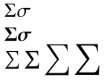Pretest sumUp Method

public static void main(String [] args)

{

int[] N = {-6, 0, -1, 5, 7};

System.out.println("My sum = " + sumUp(N));

}

public static int sumUp(int[] N)

{

int sum = 0;

for (int i = 0; i < N.length; i++)

sum += N[i];

return sum;

}

public static int sumUp(int[] N)

{

int sum = 0;

for (int i : N)

sum += i;

return sum;

}